**REACT**

**Hands On – 2**

Create a react app for Student Management Portal named StudentApp and create a component named Home which will display the Message “Welcome to the Home page of Student Management Portal”. Create another component named About and display the Message “Welcome to the About page of the Student Management Portal”. Create a third component named Contact and display the Message “Welcome to the Contact page of the Student Management Portal”. Call all the three components.  
  
**Steps:**

1. Install Create-react-app by running the following command
2. To create a React Application with the name of “myfirstreact”, type the following command:
3. Open the folder of StudentApp in Visual Studio Code
4. Create a Component file in Src Folder Consist Home, About and Contact
5. Remove the current content of “App.js”
6. Replace it with the following:

App.js

import React from 'react';

import Home from './Components/Home';

import About from './Components/About';

import Contact from './Components/Contact';

function App() {

  return (

    <div className="App">

      <Home />

      <About />

      <Contact />

    </div>

  );

}

export default App;

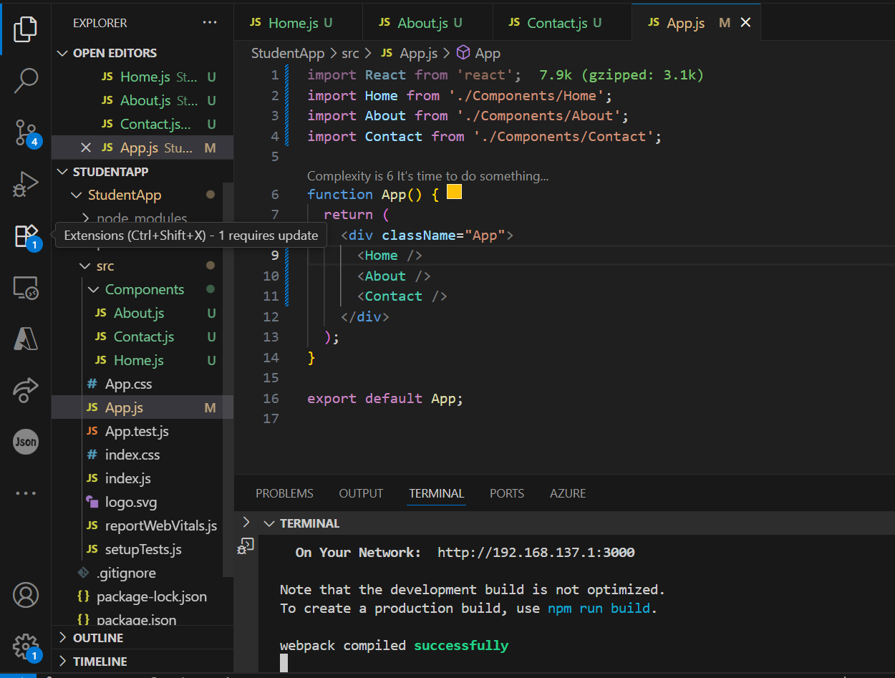

Home.js

import React from 'react';

function Home() {

  return (

    <div>

      <h2>Welcome to the Home page of Student Management Portal</h2>

    </div>

  );

}

export default Home;

About.js

import React from 'react';

function About() {

  return (

    <div>

      <h2>Welcome to the About page of the Student Management Portal</h2>

    </div>

  );

}

export default About;

Contact.js

import React from 'react';

function Contact() {

  return (

    <div>

      <h2>Welcome to the Contact page of the Student Management Portal</h2>

    </div>

  );

}

export default Contact;

**Output :**

